**Project Design Phase-II**

**Data Flow Diagram &User Stories**

|  |  |
| --- | --- |
| Date | 03October 2022 |
| Team ID | PNT2022TMID14038 |
| Project Name | Project – Exploratory Analysis of Rainfall Data in India for Agriculture |
| Maximum Marks | 4 Marks |

**Data Flow Diagrams:**

A Data Flow Diagram (DFD) is a traditional visual representation of the information flows within a system. A neat and clear DFD can depict the right amount of the system requirement graphically. It shows how data enters and leaves the system, what changes the information, and where data is stored.

Example: DFD Level 0 (Industry Standard)

**Example:**

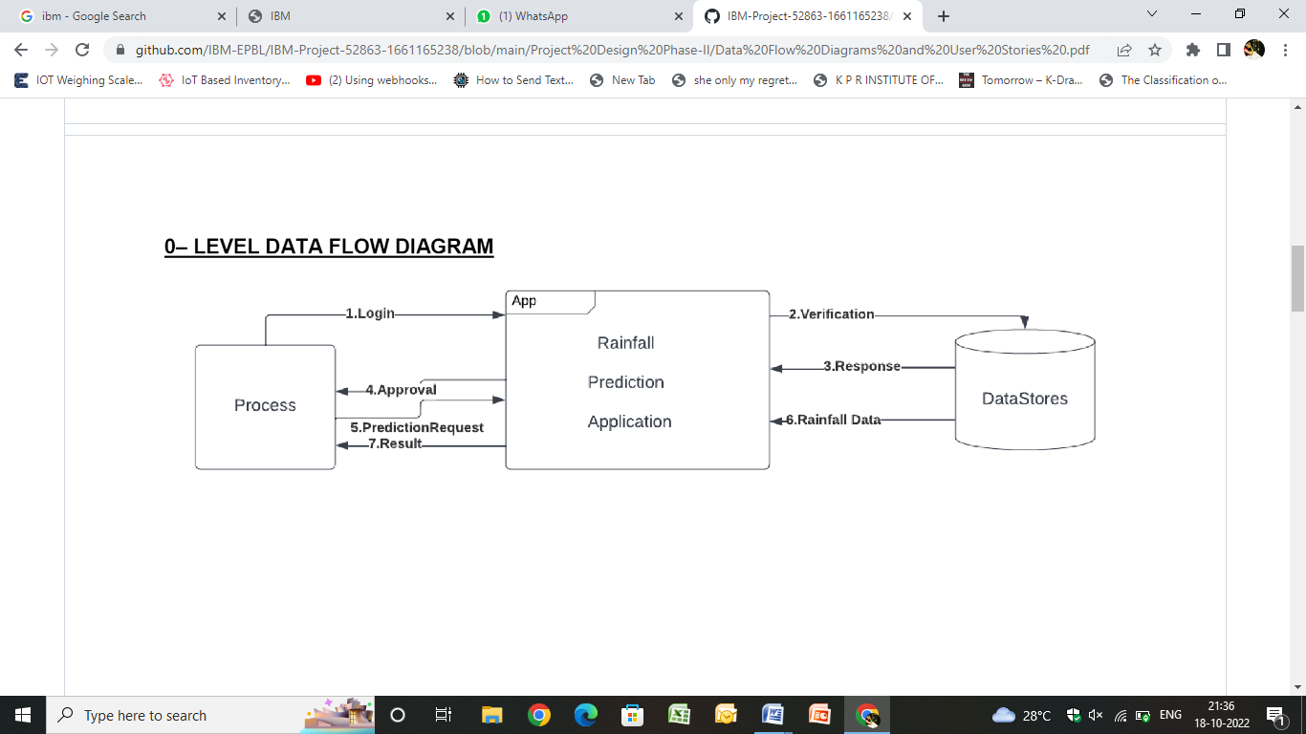

**01-LEVEL:**

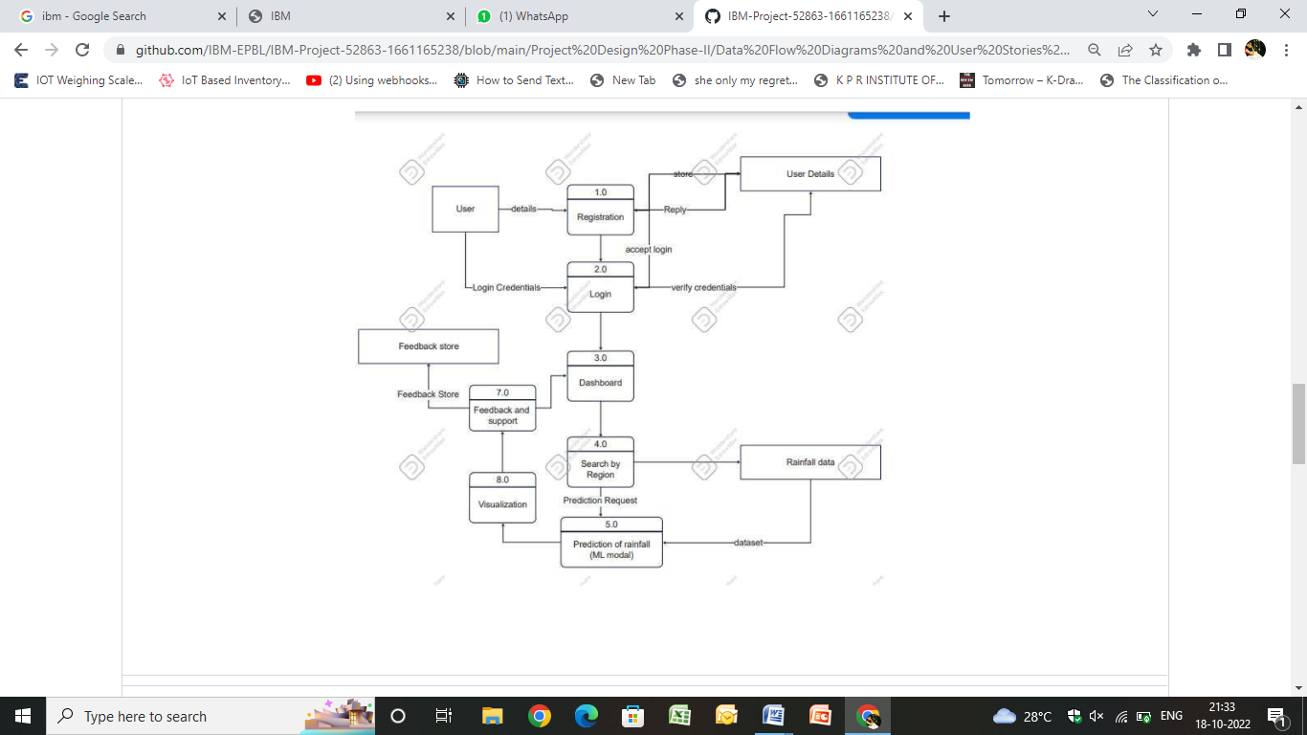

**LEVEL-02**

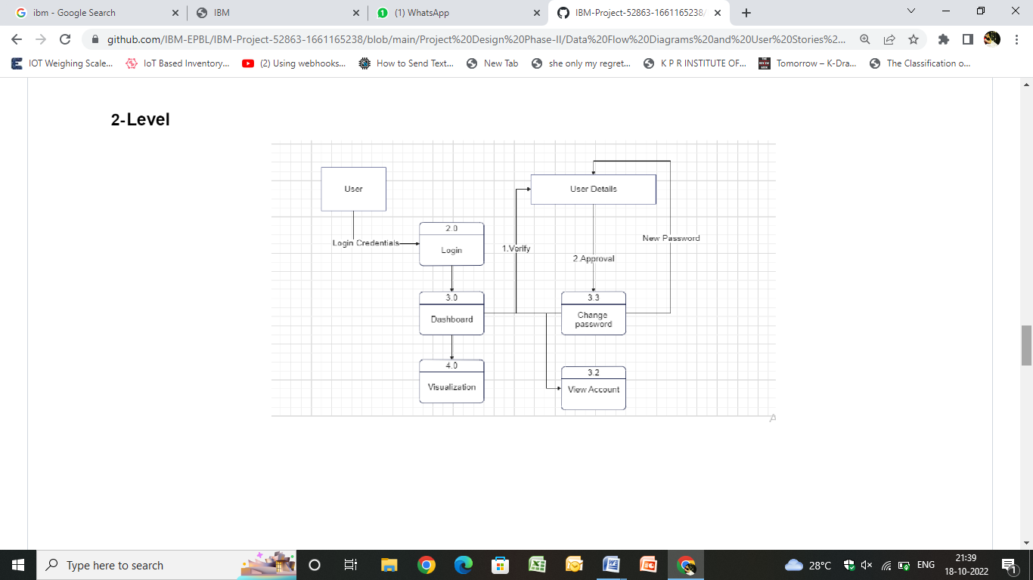

**User Stories**

|  |  |  |  |  |  |  |
| --- | --- | --- | --- | --- | --- | --- |
| User Type | Functional Equipment(EPIC) | User Story Number | User Story /Task | Acceptance criteria | priority | Release |
| Customer(web user) | Check weather | USN-1 | As a customer, I can check the rainfall by giving the region as input. | High | High | Sprint-2 |
|  | Suggested crop | USN-2 | As a customer,With the predicted rainfall I can view the suggested crops for higher productivity. | Hiigh | High | Sprint-2 |